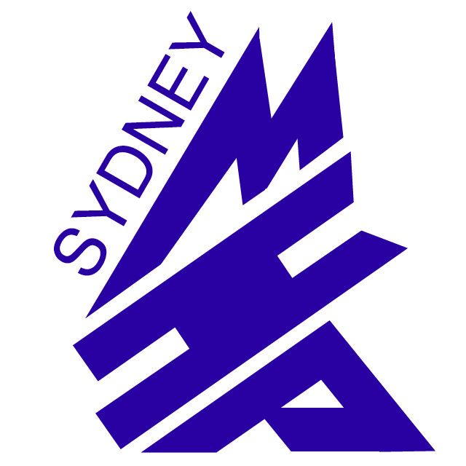
Sydney Minor Hockey Association
Player Account Clearing Form

Players Name: ________________________________

Address: ________________________________

City: ________________________________

Postal Code: ________________________________

Telephone: ________________________________

Last Seasons Team: ________________________________

Current Seasons Team: ________________________________

SMHA members (parents/players) shall be able to clear the player accounts previous years' full balance, upon making written application to the fundraising committee, after November 15th of each year. All outstanding registration fees are to be paid in full prior to the disbursement. Clearing will be done on a once per year basis only.

Players, on loan or who no longer are eligible to be members within the SMHA shall have the
accounts cleared by making written application to the fundraising committee. All balances at the time of the players’ ineligibility status in the association shall be cleared.

Payments will be made within 30 days of the fundraising committee receiving the written application. Players who leave, on their own accord, during the current year shall not be entitled to any funds in their players account and the funds shall be turned over to the SMHA general operating account upon leaving the association.

I ____________________________ hereby make application to clear my child’s SMHA player account of all eligible funds.

_______________________ _________________________________
Dated Parent/Guardian’s Signature

For office use only

Cheque # Issued __________________

Even Split Balance $_______________ Cheque Date __________________

Fundraising Treasurer_________________ SMHA Treasurer _______________________

